Run Your Own VPN

(for less than $5 a month)

Any company that allows employees to connect to their network remotely does so with a Virtual Private Network, or VPN. There are two primary benefits to using a VPN for this purpose.
- Access Control
Connecting to a VPN requires a username and password, a certificate, a PIN code, or a combination of these and other things. The group managing the VPN controls who can connect by issuing, and revoking, these access credentials as needed.
- Security
When connecting to the company network, they have no way to check the security of the network you’re coming from. It’s not possible to ensure you’re not using a spoofed WiFi hotspot at the airport, or that the coffee shop isn’t logging all of your network traffic.
With a VPN, all of your network traffic is encrypted between your device and the VPN server. No one can read your data, even if they’re watching all of it pass by.
Today we’re all carrying around intimate details of our personal lives everywhere we go; information we need to protect while at the airport, or that coffee shop. You may be able to use your company’s VPN. But what if company policy forbids personal use? Or you just don’t trust your employer with everything on your phone?
All you need is your own server and VPN software. Simple, right?

Actually it is. Amazon Lightsail is one of the easiest and least expensive ways to get your own “server in the cloud”, for as little as $3.50 a month.
OpenVPN provides all of the software you need. You can download clients for Windows, MacOS, Linux, Android, and iOS. In the next section I’ll walk you through the steps to create an Amazon Lightsail instance, with the VPN server software installed, secured and ready to use.
Before we begin, you’ll need an AWS account. Your credit card will not be charged until you’ve created resources in your account. If you’re comfortable with a command line, and AWS IAM, skip to the end of this article. I’ve provided a shell script that automates all of these steps.
Ok, here we go!

- Open the Amazon Lightsail console

- Click the Create instance button

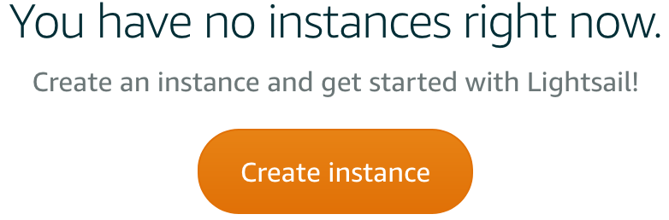

Make sure you’re creating the instance in the AWS Region closest to you. I live in New England, so Virginia and Montreal are my best choices.

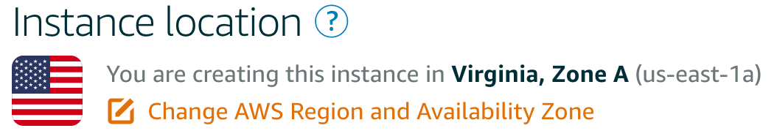
- Click the OS Only button, below Select a blueprint

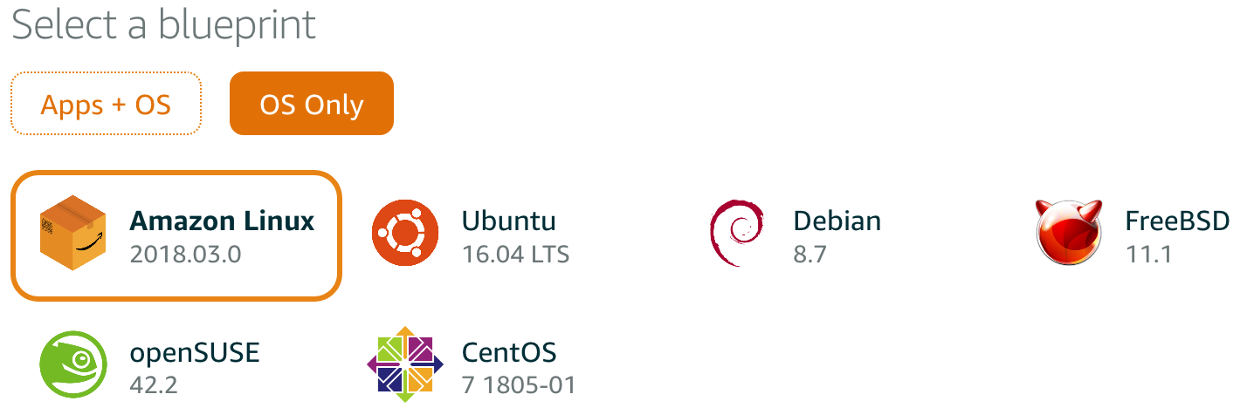
- Click Add launch script

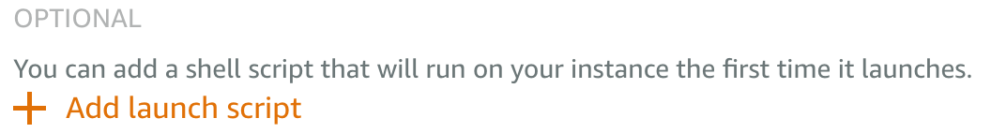
- Download this file and paste the contents into the box

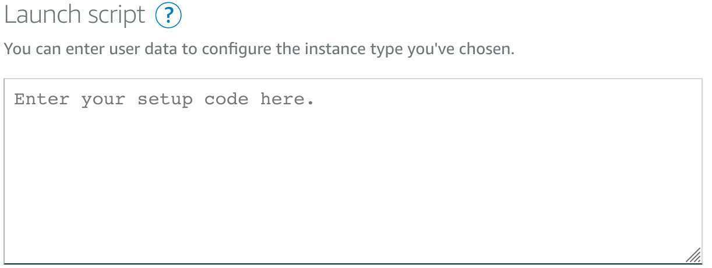
This is the userdata script that handles all of the server configuration.

- Click the Create button at the bottom



- Make a note of the instance’s IP address

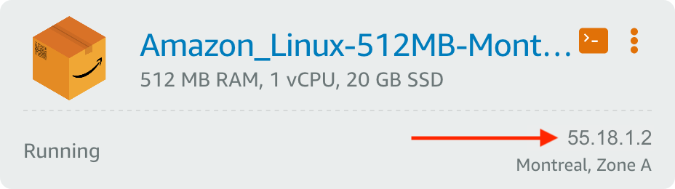
We’ll need this later.
- Download your SSH key

Lightsail creates a default SSH key pair in each region. You can download it from the Account page. It acts as your password on the server.

- Download client certificates and keys

The launch script created client configuration files that you need to install on each of your devices. These are .ovpn files containing your VPN configuration and access credentials.

You’ll need an SCP client, such as FileZilla or WinSCP. Use these settings to connect to your server:

Hostname: <your server’s IP address>
Username: ec2-user
Password: <none, use the SSH key file instead!>

Download the entire /tmp/ovpn directory.

- Configure the firewall

Now that you have your client configuration files, you should secure your server by blocking access to unused services.

- From the main Lightsail page, click on your instance
- Open the Networking tab
- In the Firewall section, click Edit rules
- Click each X to delete the rules for SSH and HTTP
- Click Add rule
- Change Protocol to UDP
- Enter 1194 in Port range
- Click Save

It should look like this:

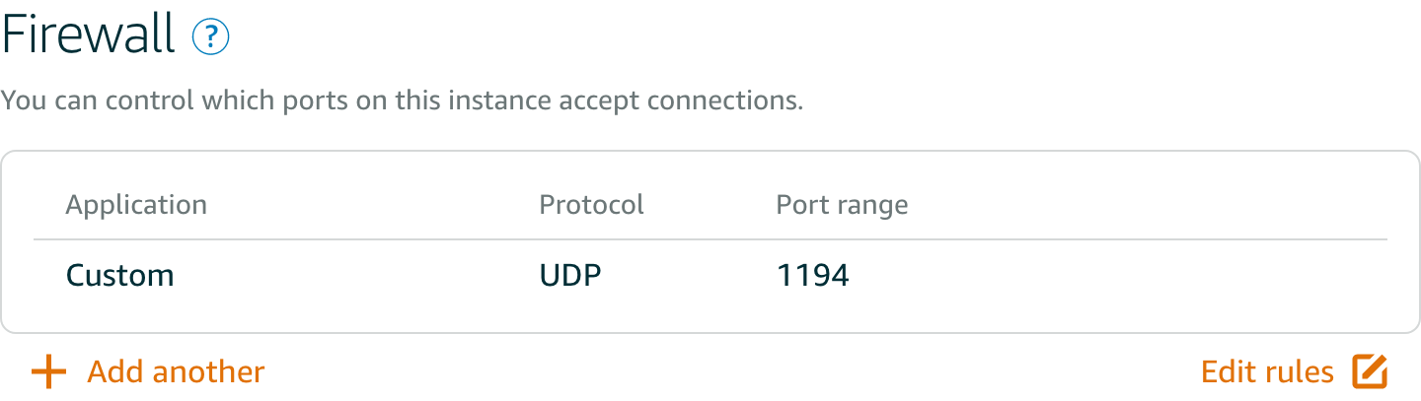
- Configure your devices

All that’s left is to load your ovpn files onto your devices. Security best practice is to use a different file for each one.

On desktops and laptops with MacOS or Windows, just double-click on one of the files.

To get a client configuration file onto an iOS or Android device you can use a file sharing service, like Dropbox. Or you can email it to yourself.

Welcome advanced user!

I practically made a career out of writing shell scripts. While userdata.sh automates the OpenVPN installation and configuration on the server, I also wrote mkvpn.sh to automate everything else.

- Create an IAM access key
- Install the AWS Command Line Interface
sudo pip install awscli -U
- Download mkvpn.sh and userdata.sh
- Run mkvpn.sh
./mkvpn.sh
- Configure your devices (step 11)

mkvpn.sh also creates a Static IP address, a disk volume, and snapshots the disk volume. These can help you recover from an instance failure. The first rule of cloud computing is design for failure. The second rule of cloud computing is design for failure.
Using a static IP address means you wouldn’t need to install new client configuration files on your devices. The disk volume stores /var/openvpn, which has all of your certificates and keys. The disk volume costs 80 cents per month. The snapshot costs 40 cents per month. With these extras, your total monthly cost would be $4.70/mo.
Congratulations! You now have your very own Virtual Private Network, with 1 TB of data transfer, for less than 5 bucks a month.

